**Step 1: Verify AWS Storage Gateway in AWS Console**

1. Log in to the AWS Management Console.
2. Navigate to the **Storage Gateway** service.
3. Click on **Create Gateway**.

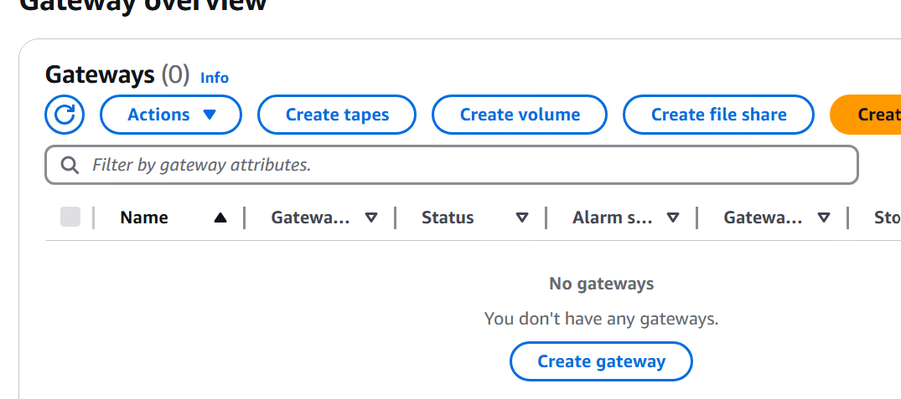

**Step 2: Configure Storage Gateway**

1. Provide a unique name for the Storage Gateway.
2. Select **VMware ESXi** as the platform.
3. Download the **OVA** template provided by AWS.

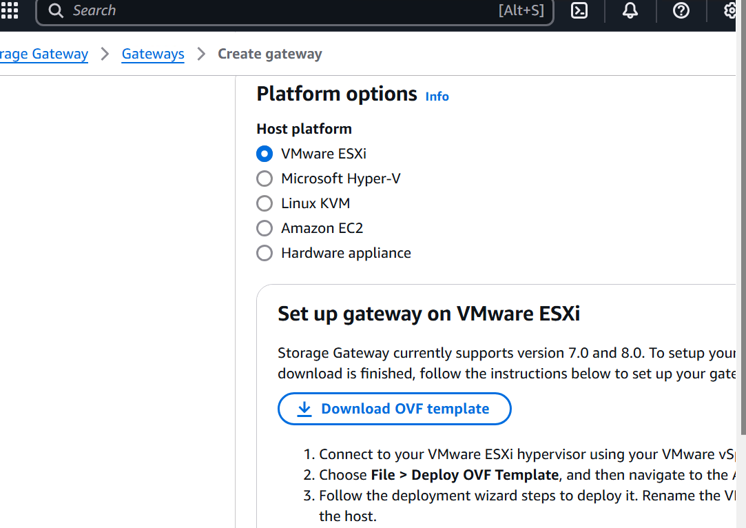

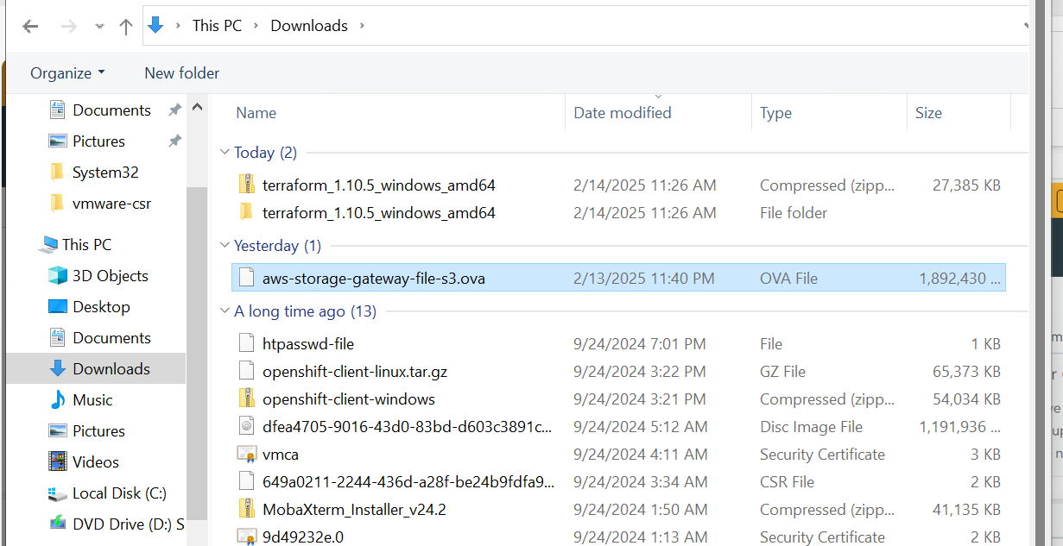

**Step 3: Deploy the OVA Template in VMware ESXi**

1. Connect to your VMware ESXi hypervisor using the **VMware vSphere Client**.
2. Click on **File > Deploy OVF Template**.
3. Navigate to and select the downloaded **AWS Storage Gateway OVA template**.
4. Follow the deployment wizard steps to deploy the virtual machine (VM).
5. Rename the VM to avoid confusion with other imported VMs.
6. When prompted, select a suitable **data store** to store the OVA package.
7. For **Select Storage**, choose **Thick provisioned virtual disk format**.

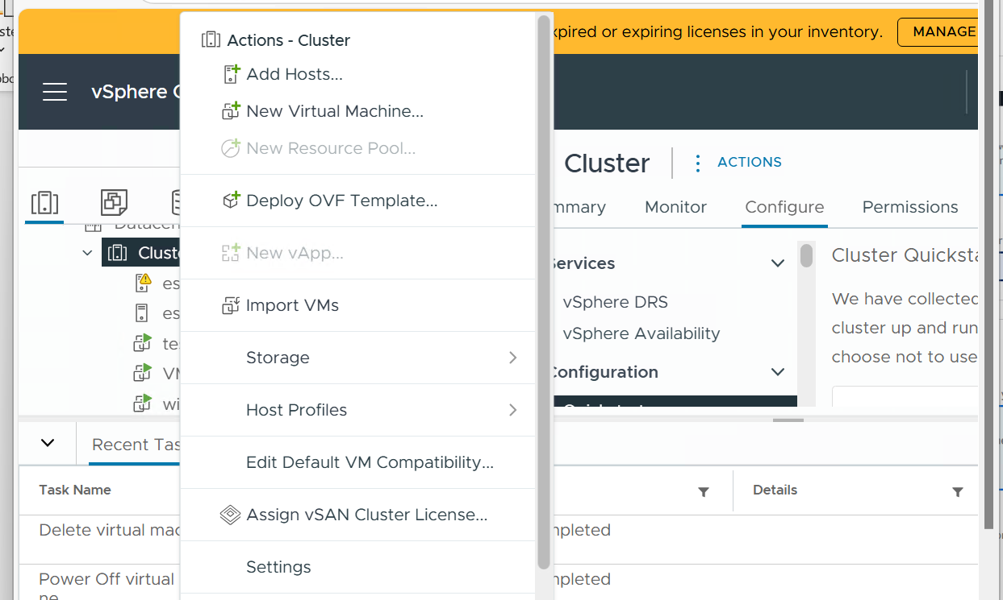

**Step 4: Configure Virtual Machine Settings**

1. Once the VM is deployed, navigate to **Edit Settings**.
2. Click **Add New Device > Hard Disk**.
3. Allocate at least **80 GiB** for cache storage (additional local disks recommended for better performance).
4. Configure **proper networking settings**.

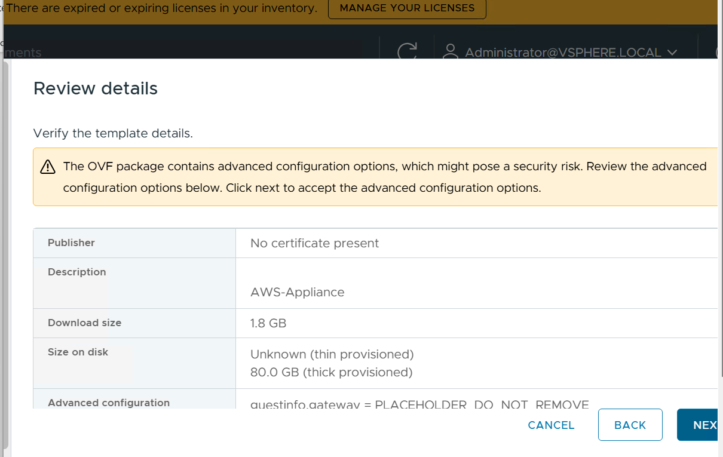

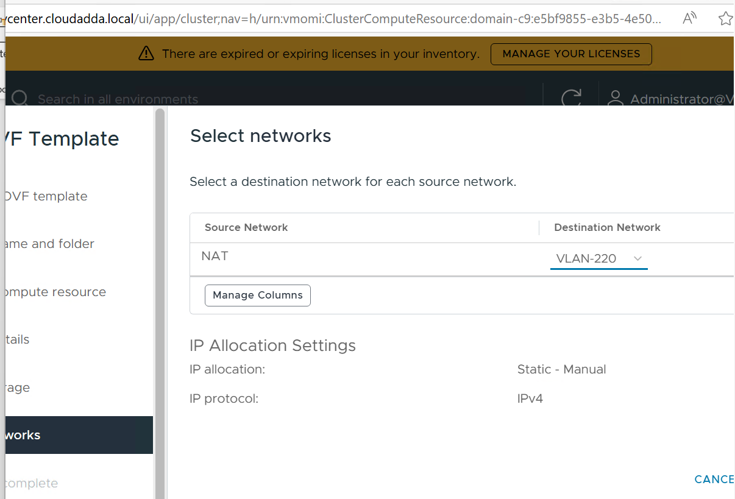

**Step 5: Configure VMware Tools and Time Synchronization**

1. Go to **Edit Settings > Options > VMware Tools**.
2. Under **Advanced**, select **Synchronize guest time with host**.
3. Click **OK** to save changes.
4. Ensure that the **host clock is correctly set** and synchronized with a **Network Time Protocol (NTP) server**.

**Step 6: Power On and Validate the VM**

1. **Power on** the virtual machine.
2. Confirm successful deployment and proper configuration.
3. Verify network connectivity and storage allocation.